Case 14-AM,C-Costa Rica-Nicoya-Guanacaste-Axe God-Jadeite-Early Late Preclassic-300 BCE

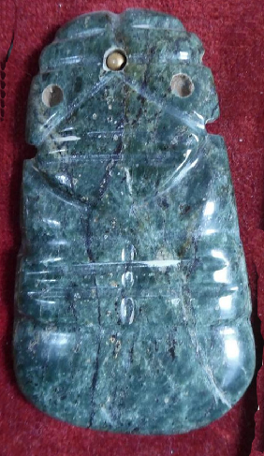 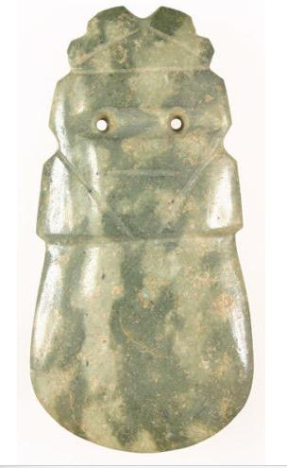 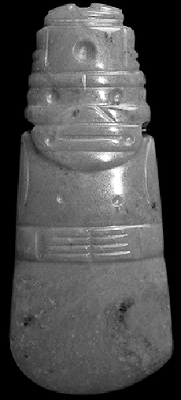

Fig. 1a. Costa Rica-Nicoya-Guanacaste-Axe God-Jadeite-Early Late Preclassic-300 BCE, Middle Motagua Valley, Atlantika Collection.

Fig. 1b. Costa Rica-Nicoya-Guanacaste-Axe God-Jadeite-Early Late Preclassic-300 BCE, [jacksonsonmain](https://picclick.com/seller/jacksonsonmain) Mount Sterling, KY; Item no.160603634278, $2,800.

Fig. 1c. Costa Rica-Nicoya-Guanacaste-Axe God-Jadeite-Early Late Preclassic-300 BCE, Curation International, Lexington, KY, $1,200.00.

Case no.:

Accession Number:

Formal Label: Costa Rica-Nicoya-Guanacaste-Axe God pendant-Jadeite

**Display Description:**

Jade’s significance for pre-Columbian Nicoya-Guanacaste prehistory extends beyond its obvious aesthetic appeal to the intensification of an imposed social hierarchy. Since no sources of jade were within the bounds of modern Costa Rica ([Bishop, Sayre and Mishara, 1985](https://revistas.ucr.ac.cr/index.php/antropologia/article/view/25274/25732" \l "Bishop--R.-L.--Sayre--E.-V.-and-Mishara--J.--1985-); [Lange and Bishop, 1988](https://revistas.ucr.ac.cr/index.php/antropologia/article/view/25274/25732" \l "Lange--F.-W.-and-Bishop--R.-L.--1988-.); [Lange, Bishop and van Zelst, 1981](https://revistas.ucr.ac.cr/index.php/antropologia/article/view/25274/25732" \l "Lange--F.-W.--Bishop--R.-L.-and-van-Zelst--L.--1981-.)), jade must have been quarried by the Nicoya-Guanacaste elsewhere. The sole source of this mineral was in the land of the Olmec and the Maya to the north in the Middle Motagua Valley ([Gendron, Smith and Gendron-Badou, 2002](https://revistas.ucr.ac.cr/index.php/antropologia/article/view/25274/25732" \l "Gendron--F.--Smith--D.-C.-and-Gendron-Badou--A.--2002-); [Seitz et al., 2001](https://revistas.ucr.ac.cr/index.php/antropologia/article/view/25274/25732" \l "Seitz--R.--Harlow--G.-E.--Sisson--V.-B.-and-Taube--K.-A.--2001-); [Taube et al., 2004](https://revistas.ucr.ac.cr/index.php/antropologia/article/view/25274/25732" \l "Taube--K.-A--Sisson--V.-B.--Seitz--R.-and-Harlow--G.-E.--2004-.)). The rise of the Axe-God ateliers began at ca 300 BCE and lasted to ca 600 CE at which point a decline settled in and by ca 900 CE few ateliers were left in the orbit of the Nicoya-Guanacaste ([Guerrero, 1998](https://revistas.ucr.ac.cr/index.php/antropologia/article/view/25274/25732" \l "Guerrero--J.-V.--1998-)). Thisrise and decline of a material culture event parallels the rise and decline of the religion of the Nicoya-Guanacaste people and suggests that two interconnected social and ideational phenomena were linked: the social phenomenon was tied to a model of the rise of dispersed villages rather than one large nucleated town tht over time evolved into an increasingly centralized structure even though it was dispersed, while the ideational tradition rose with the localized energies of individual control and then went into decline as a more normative structure of conformity was introduced ([Guerrero, 1998](https://revistas.ucr.ac.cr/index.php/antropologia/article/view/25274/25732" \l "Guerrero--J.-V.--1998-)). The decline of the Axe-God ateliers began at ca 600 CE and by ca 900 CE few were left in the orbit of the Nicoya-Guanacaste ([Guerrero, 1998](https://revistas.ucr.ac.cr/index.php/antropologia/article/view/25274/25732" \l "Guerrero--J.-V.--1998-)). The decline of the Axe-God ateliers began at ca 600 CE and by ca 900 CE few were left in the orbit of the Nicoya-Guanacaste ([Guerrero, 1998](https://revistas.ucr.ac.cr/index.php/antropologia/article/view/25274/25732" \l "Guerrero--J.-V.--1998-)). This parallels the decline in the religion of the Nicoya-Guanacaste people and suggests that two interconnected social and ideational phenomena were linked: the social phenomenon was tied to a model of dispersed settlements of increasingly politically affiliated villages rather than one large nucleated town, while the ideational tradition went into decline as a more normative structure of religious conformity was introduced that greatly reduced the number of independent jade-working centers in the orbit of the Nicoya-Guanacaste culture ([Guerrero, 1998](https://revistas.ucr.ac.cr/index.php/antropologia/article/view/25274/25732" \l "Guerrero--J.-V.--1998-)). The decline of the Axe-God ateliers began at ca 600 CE and by ca 900 CE few were left in the orbit of the Nicoya-Guanacaste ([Guerrero, 1998](https://revistas.ucr.ac.cr/index.php/antropologia/article/view/25274/25732" \l "Guerrero--J.-V.--1998-)). The manufacturing of jade objects such as the Axe-God pendants evolved in tandem with the development of an increasingly structured social system.The Pre-Columbian jade lapidary tradition that rose and declined between 500 BCE and 900 CE encompassed an intense localized, independent cultural activity ca 300-700 ([Snarskis, 2003](https://revistas.ucr.ac.cr/index.php/antropologia/article/view/25274/25732" \l "Snarskis--M.-J.--2003-.); [Guerrero, 1998](https://revistas.ucr.ac.cr/index.php/antropologia/article/view/25274/25732" \l "Guerrero--J.-V.--1998-)) as trade and exchange of finished jade Axe-God objects were traded with the Olmec and the Maya (see Mora-Marín 2008, 2002;; [Fields and Reents-Budet, 1992](https://revistas.ucr.ac.cr/index.php/antropologia/article/view/25274/25732" \l "Fields--V.-M.-and-Reents-Budet--D.-J.--1992-); [Hoopes, 1985](https://revistas.ucr.ac.cr/index.php/antropologia/article/view/25274/25732" \l "Hoopes--J.-W.--1985-.); [Lange, 1986](https://revistas.ucr.ac.cr/index.php/antropologia/article/view/25274/25732" \l "Lange--F.-W.--1986-); [Sharer, 1984](https://revistas.ucr.ac.cr/index.php/antropologia/article/view/25274/25732" \l "Sharer--R.-J.--1984-.); [León, 1982](https://revistas.ucr.ac.cr/index.php/antropologia/article/view/25274/25732" \l "Le-n--M.--1982-); [Walters, 1982](https://revistas.ucr.ac.cr/index.php/antropologia/article/view/25274/25732" \l "Walters--G.-R.--1982-); [Stone, 1964](https://revistas.ucr.ac.cr/index.php/antropologia/article/view/25274/25732" \l "Stone--D.--1964-); [Easby, 1963](https://revistas.ucr.ac.cr/index.php/antropologia/article/view/25274/25732" \l "Easby--E.-K.--1963-).). This ushered in a pan-Mesoamerican cultural florescence (Mora-Marin 2016).

Since most of the Costa Rican Avian Axe-God Theme (AvAGT) figurines and the Anthropomorphic Axe-God Theme (AAGT) figurines were prepared for personal apparel as pendants and amulets, they were drilled with holes to allow them to be used as pendants, whereas Mesoamerican (Olmec and Maya) figural jades were mostly undrilled and used primarily as offerings in ritual caches. This sociological differentiation highlighted the Nicoya-Guanacaste sense of individual (and local) identity and social parity, while the Mesoamerican sense of corporate identity assumed a hierarchically structured ritual behavior. The Nicoya-Guanacaste exhibited local identities reflecting disparate social and religious awarenesses that influenced their visual expressions of often separately evolving ritual behaviors. These sometimes disparate ritual and visual behaviors differed from the corporate ritual and visual behaviors among the Olmec and the Maya that often reflected adherence to normative religious structures.

However, the Nicoya-Guanacaste provided at least one of their AvAGT drilled jadeite figurines (radio-carbon dated to ca 500 BCE) to the Pacific northwest village of La Regla ([Guerrero, Solís and Solano, 1992](https://revistas.ucr.ac.cr/index.php/antropologia/article/view/25274/25732" \l "Guerrero--J.-V.--Sol-s--F.-and-Solano--F.--1992-.)). This village was nearer to the sole sources of jade outcrops of the Middle Motagua Valley of East-Central Guatemala. In addition, a drilled the Nicoya-Guanacaste jade pendant import was found in a cache near the site of Chaksinkin, Yucatan, Mexico (Andrews [1986a](https://revistas.ucr.ac.cr/index.php/antropologia/article/view/25274/25732" \l "Andrews-V.--E.-Wyllys-V.--April-1986a-), [1986b](https://revistas.ucr.ac.cr/index.php/antropologia/article/view/25274/25732" \l "Andrews-V.--E.-Wyllys-V.--1986b-), [1987](https://revistas.ucr.ac.cr/index.php/antropologia/article/view/25274/25732" \l "Andrews-V.--E.-Wyllys-V.--1987-)) where ceramic stratigraphy places this find at ca 300 BCE. Therefore, in the period 500-300 BCE the Nicoya-Guanacaste people were actively exchanging their ideational concepts and pendants of the Axe-God with the Maya and the Olmec and were probably receiving from them ideas about Mesoamerican hierarchically structured religion and ritualism.

The decline of the Axe-God ateliers began at ca 600 CE and by ca 900 CE few were left in the orbit of the Nicoya-Guanacaste ([Guerrero, 1998](https://revistas.ucr.ac.cr/index.php/antropologia/article/view/25274/25732" \l "Guerrero--J.-V.--1998-)). This material cultural shift parallels the decline in the local religion of the Nicoya-Guanacaste people and suggests that two interconnected social and ideational phenomena were linked: the social phenomenon was tied to a model where dispersed settlements were increasingly controlled from without, even though their villages did not evolve into one large nucleated town. The decline of the Nicoya-Guanacaste ideational tradition of localized religious expression contributed to the decline in the number of independent jade-working centers as a more normative structure of religious conformity was introduced ([Guerrero, 1998](https://revistas.ucr.ac.cr/index.php/antropologia/article/view/25274/25732" \l "Guerrero--J.-V.--1998-)).

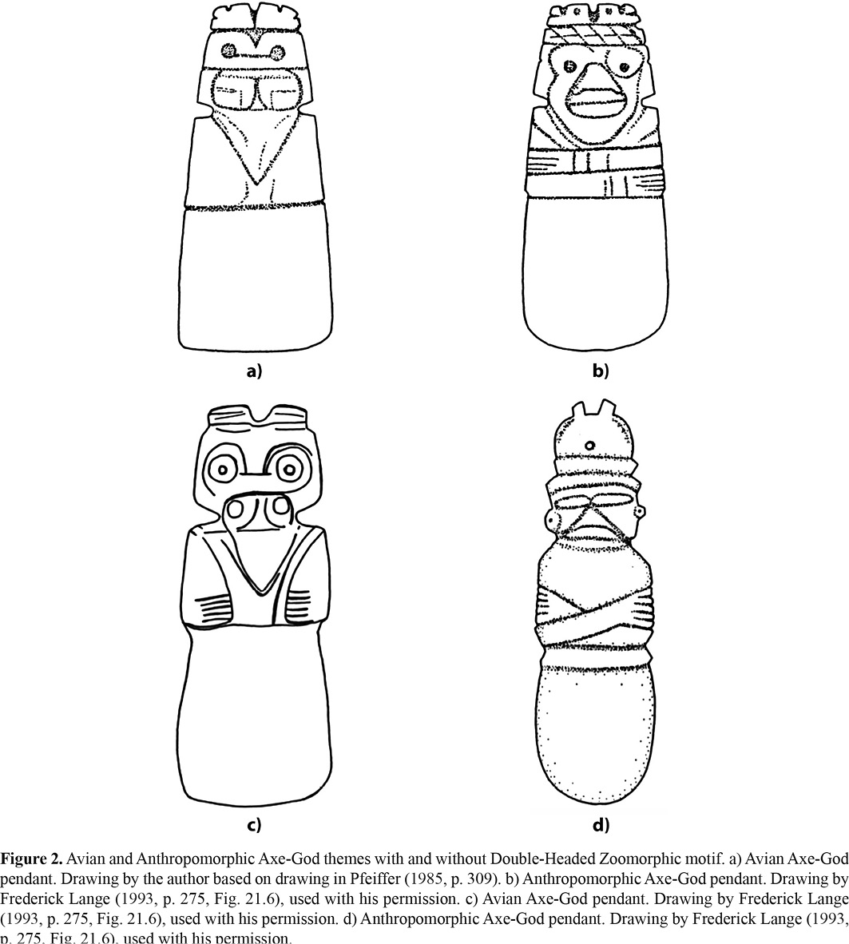

**LC Classification:** NK5750

Date or Time Horizon: early Late Preclassic (300 BCE)

Geographical Area: Costa Rica-Nicoya-Guanacaste

**Map:**

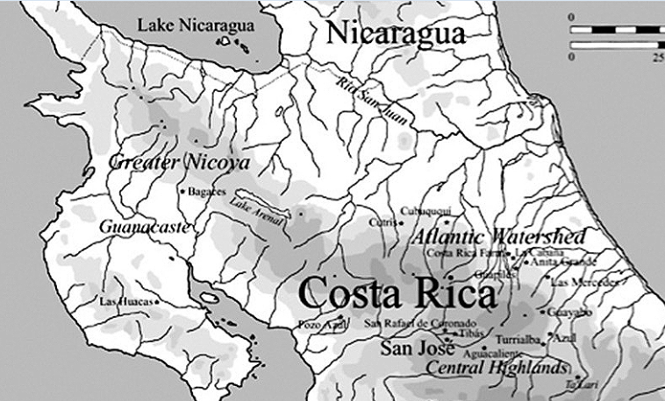

Fig. 2e. Costa-Rican Archaeological regions showing Las Huacas, which has been used as the geographical reference point, since the exact find location is unknown (map after Hoopes 1985)

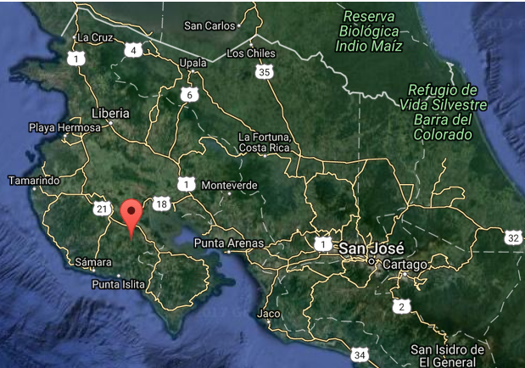

Fig. 2f. Costa-Rican Archaeological regions showing Las Huacas, which has been used as the geographical reference point, since the exact find location is unknown (map after National Geospatial-Intelligence Agency, Bethesda, MD, USA: https://geographic.org/geographic_names/name.php?uni=-1637868&fid=1438&c=costa_rica)

**GPS coordinates:** 10° 02' 00" N, 85° 20' 00" W

Cultural Affiliation: early Late Preclassic (300-200 BCE)

Medium: Jadeite

Dimensions:

Weight:

Condition: original

Provenance:

**Discussion:** Most of what follows is taken from the excellent paper ofProf.David F. Mora-Marín, UNC, Chapel Hill, NC: see Mora-Marin 2016.

Prior to the arrival of the Spanish the territory on the eastern shore of the Gulf of Nicoya was inhabited by the "Chorotega" or "*Choluteca,*" which in the [Nahuatl language](https://wikivisually.com/wiki/Nahuatl_language) "*Cholōltēcah*" means "inhabitants of Cholula" or "people who have fled". (Daniel G. Brinton. 1886. Notes on the Mangue; An Extinct Dialect Formerly Spoken in Nicaragua Proceedings of the American Philosophical Society , Vol. 23, No. 122 (Apr., 1886), pp. 238-257 ) Among these people were the original inhabitants of [Cholula](https://wikivisually.com/wiki/Cholula_(Mesoamerican_site)), who had been displaced by the immigrtion of [Nahua](https://wikivisually.com/wiki/Nahua_peoples) people into central Mexico.

Also, prior to the arrival of the Spanish conquistadores the territory in the zone of [Bagaces](https://wikivisually.com/wiki/Bagaces) was inhabited by the Nahuas or Aztecans. When conquistador [Gil Gonzalez Dávila](https://en.wikipedia.org/wiki/Pedrarias_Dávila) entered the region controlled by cacique Nicoya in 1523, it was the largest [*cacicazgo*](https://en.wikipedia.org/wiki/Cacique) (chiefdom) on the Pacific coast of Costa Rica. Nicoya in the [Nahuatl](https://en.wikipedia.org/wiki/Nahuatl) language of the Aztecs is *Necoc Īāuh*, literally "on both sides its water(s)," and the region around the town of Nicoya is in fact situated between two major rivers. Several large (5–10 hectare/12–24 acre) archaeological sites were in similar ecological niches throughout the valley. They are situated along river and stream banks at the point where streams leave the hills that surround the valley and cross the undulating valley floor.

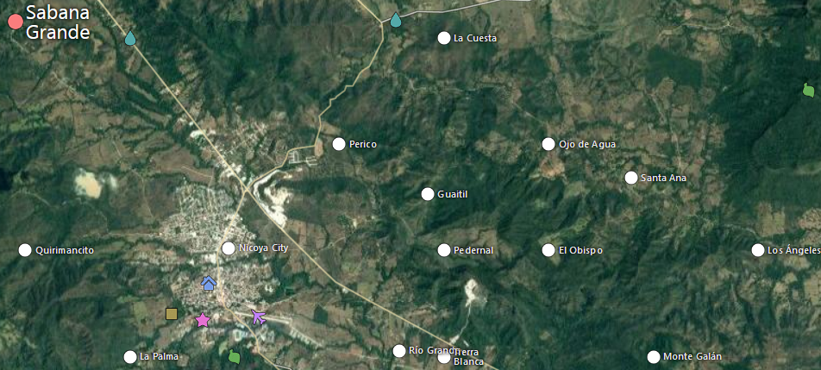

Map showing the town of Sabana Grande and villages to the southwest that may have been under the influence of the caciques Nicoya and Mateo. From https://mapcarta.com/19589736/Map.

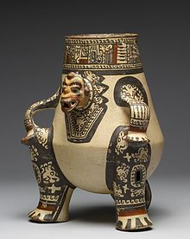

This [Pataky](https://en.wikipedia.org/wiki/Pataky) ceramic (late Period VI, AD 1000-1350) portrays a seated [shaman](https://en.wikipedia.org/wiki/Shaman) transformed into a [jaguar spirit](https://en.wikipedia.org/wiki/Jaguars_in_Mesoamerican_cultures) companion form.

Two of these sites are considered likely candidates for the town of caciques Mateo and Nicoya. One is just outside contemporary Nicoya along the banks of the [Rio Chipanzé](https://en.wikipedia.org/w/index.php?title=Rio_Chipanzé&action=edit&redlink=1), and this may have been cacique Mateo’ home town. The other is in the hamlet of [Sabana Grande](https://en.wikipedia.org/w/index.php?title=Sabana_Grande,_Costa_Rica&action=edit&redlink=1), six kilometers north of Nicoya. This site appears to be larger than the rest and it may have been the hometown of cacique Nicoya. It exhibits low earthen mounds and is particularly prized by local looters for its high-quality polychrome pottery and gold artifacts. Apparently a much greater quantity of high-quality artifacts have been removed from the vicinity of Sabana Grande than from anywhere else in the valley. Therefor, it is possible that the colonial *ejido* or lands held in common by the indigenous community was centered in Sabana Grande.

Andrés de Cereceda, treasurer of Gil Gonzalez Dávila's 1522 expedition observed "The chief Nicoya is five leagues further on, inland: they baptized 6,603 souls; he gave 13,442 pesos in gold, with a little more that the chief Mateo gave" (Peralta 1883:30; Oviedo y Valdez 1959. Cereceda's figure of 6,603 is typically taken to represent the number of inhabitants of the *cacique* Nicoya's town, but Cereceda never makes that assertion, only that the expedition baptized that number of people. Furthermore, he refers to a second chief, Mateo, whose residence was never specified.

An alternative interpretation of Cereceda's figures would understand them as representing the inhabitants of several dispersed settlements politically affiliated with the caciques Nicoya and Mateo but not members of one massive community. This better fits the archaeological and ethnohistoric information. Oviedo, who visited the town of Nicoya in 1529 before the precipitous population decline had taken its effect, recorded aspects of the town's layout but never remarked on the great size of the settlement. While the *cacique* Nicoya may not have had tributary villages under his direct control it is not unlikely that there were several villages within his orbit of influence from his town of Sabana Grande and Mateo’s town along the banks of the [Rio Chipanzé](https://en.wikipedia.org/w/index.php?title=Rio_Chipanzé&action=edit&redlink=1). Therefore, dispersed settlements of politically affiliated villages rather than one large nucleated town was probably the model of the region.

The only published radiocarbon date associated with a pendant carved in the Anthropomorphic Axe-God Theme (AAGT) comes from the site of Severo Ledesma, Atlantic Watershed, Costa Rica (Figure 4a), dated also by associated radiocarbon remains to 350 ± 60 CE ([Guerrero, 1998](https://revistas.ucr.ac.cr/index.php/antropologia/article/view/25274/25732" \l "Guerrero--J.-V.--1998-)). Consequently, there would seem to be a significant gap, of roughly eight-to-nine centuries, between the emergence of the Avian Axe-God Theme (AvAGT) and the emergence of the AAGT.

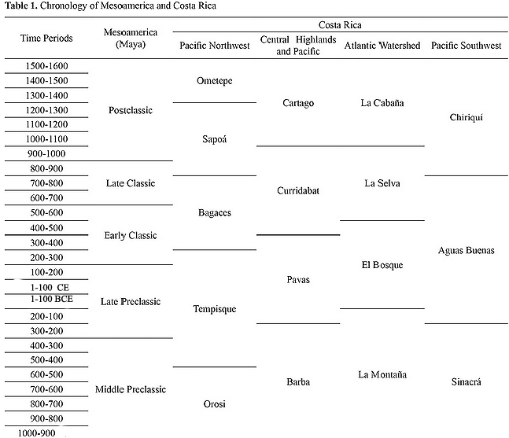

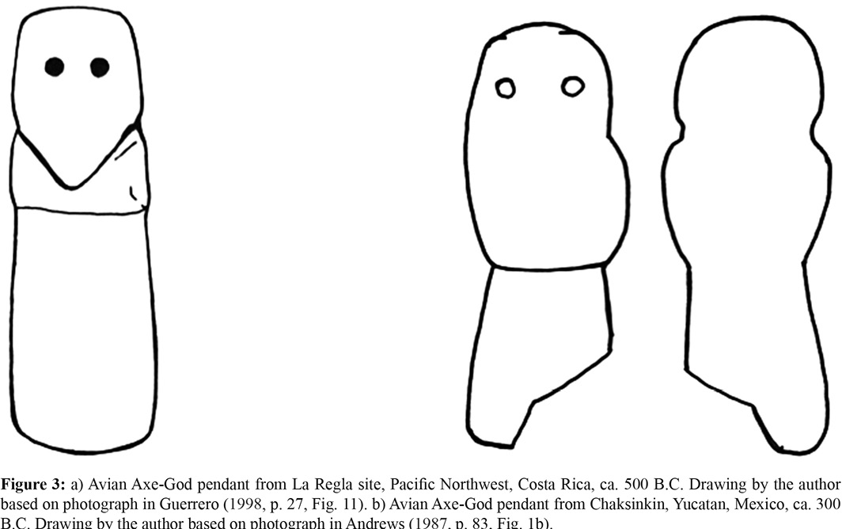

Drawing by David F. Mora-Marín, UNC, Chapel Hill, NC.

Nicoya-Guanacaste ?

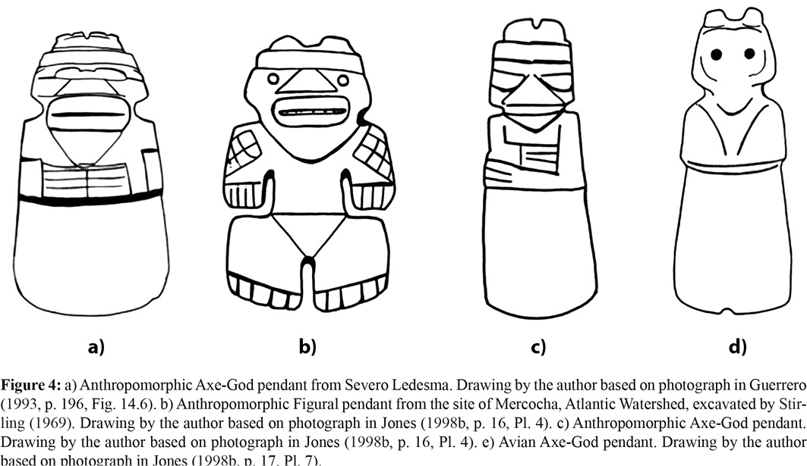

Drawing by David F. Mora-Marín, UNC, Chapel Hill, NC.

Prior to this, at the site of Mercocha, Atlantic Watershed, Costa Rica, an AAGT Pendant (Figure 4b) was recovered by [Stirling (1969)](https://revistas.ucr.ac.cr/index.php/antropologia/article/view/25274/25732" \l "Stirling--M.-W.--1969-), together with a “mace head of blue thompsonite in the form of a human head” from the pit of a stone mound of circular shape; the associated charcoal yielded a date of ca. CE 144, I-1436, 1820±140 BP, 103-545 CE ([Stirling, 1969](https://revistas.ucr.ac.cr/index.php/antropologia/article/view/25274/25732" \l "Stirling--M.-W.--1969-)). The form of this AAGT Pendant is suggestive of the beginnings of the AAGT: the head, with all of its details, is rendered indistinguishably from the later Axe-God counterparts, while the legs reveal a shape that resembles the outline of the blade motif of the Axe-God representations, but no blade per se is shown. Also, the Mercocha and Severo Ledesma figures share a very similar stylistic realization of the facial details: the nose is triangular, the mouth is broad and oval, and the chin is triangular, as though meant to make allusion to the beak of the bird of the AvAGT. Several anthropomorphic AAGT pendants from the site of Las Huacas, Pacific Northwest, Costa Rica ([Hartman, 1907](https://revistas.ucr.ac.cr/index.php/antropologia/article/view/25274/25732" \l "Hartman--C.-V.--1907-.)), dated based on ceramic associations to ca. 300-500 CE ([Hoopes, 2005](https://revistas.ucr.ac.cr/index.php/antropologia/article/view/25274/25732" \l "Hoopes--J.-W.--2005a-.)), bear these same attributes; one of these (Figure 4c) bears the double-tufted head crest also seen with the Mercocha pendant. In fact, this double-tufted head crest is also seen in another pendant from Mercocha, only this time it is a representation of an AvAGT (Figure 4d). Because of these stylistic affinities between the Mercocha pendant and those from Severo Ledesma and Las Huacas, and the broad range implied by the radiocarbon date of 103-545 A.D, it is perhaps safer to suggest a dating closer to those of the latter two sites, perhaps A.D. 300-500.

The third site, Loma Corral 3, attests to several AvAGT pendants and AAGT pendant, which have yet to be described in detail. Several of the anthropomorphic pendants resemble those from Severo Ledesma and Las Huacas. [Snarskis (2003)](https://revistas.ucr.ac.cr/index.php/antropologia/article/view/25274/25732" \l "Snarskis--M.-J.--2003-.) proposes a dating of the site based on ceramic associations consistent with “Izalco Usulután ceramics,” dated to ca. 200 BCE-100 CE. However, Paul Amaroli (personal communication, 2014) suggests that the ceramics more closely resemble the Uapala Ceramic Sphere, which he notes is not yet well defined or solidly dated. Furthermore, Amaroli notes that the revised date of the Ilopango eruption, now believed to have occurred around 534 CE, could potentially call for the redefinition of ceramic dates, for it was based on the Ilopango’s ash deposits that several scholars had previously anchored a variety of ceramic types and modes in El Salvador to 250 CE (i.e. end of Late Preclassic), a dating that implies its time horizon is more extended. Consequently, it cannot yet be established that the AAGT pendants from Loma Corral date to before 100 CE.

A hypothesis could argue that the AvAGT Mercocha jade, dated to 144 CE, may have predated the AAGT 100-300 CE. The apparent stylistic and thematic relationships between these two jade objects suggest that the AvAGT and a Proto-AAGT at Mercocha coalesced, giving rise to the formal AAGT. Furthermore, the AAGT is the Costa Rican version of the so-called “Charlie Chaplin” Figural Theme (CCFT) from the central and eastern Maya lowlands, first defined by Thompson ([1931](https://revistas.ucr.ac.cr/index.php/antropologia/article/view/25274/25732" \l "Thompson--J.-E.-S.--1931-), [1939](https://revistas.ucr.ac.cr/index.php/antropologia/article/view/25274/25732" \l "Thompson--J.-E.-S.--1939-)), which is itself simply the Maya version of an interregional theme attested in Central Mexico, Guerrero, Oaxaca, the Maya highlands, and as far south as El Salvador, suggesting a pan-Mesoamerican diffusion from the.

This conclusion, if correct, could have broad implications for the nature of archaeological research and theorizing in the region: it recognizes the need for returning to the Middle American framework utilized by archaeologists prior to Kirchhoff’s ([1943](https://revistas.ucr.ac.cr/index.php/antropologia/article/view/25274/25732" \l "Kirchhoff--P.--1943-)) definition of “Mesoamerica” and Lange and Stone’s ([1984](https://revistas.ucr.ac.cr/index.php/antropologia/article/view/25274/25732" \l "Lange--F.-W.-and-Stone--D.-Z.--1984-)) definition of “Lower Central America,” for the Costa Rican counterpart would imply a pan-Middle American distribution for the theme in question.

Middle American Jade Traditions

Several jade and greenstone lapidary traditions developed in Middle America, including the following: the Olmec (1150-400 BCE) ([Coe, 1965](https://revistas.ucr.ac.cr/index.php/antropologia/article/view/25274/25732" \l "Coe--M.-D.--1965-); Covarrubias, [1942](https://revistas.ucr.ac.cr/index.php/antropologia/article/view/25274/25732" \l "Covarrubias--M.--1942-), [1946](https://revistas.ucr.ac.cr/index.php/antropologia/article/view/25274/25732" \l "Covarrubias--M.--1946-), [1957](https://revistas.ucr.ac.cr/index.php/antropologia/article/view/25274/25732" \l "Covarrubias--M.--1957-); [Garber et al., 1993](https://revistas.ucr.ac.cr/index.php/antropologia/article/view/25274/25732" \l "Garber--J.-F.--Grove--D.-C.--Hirth--K.-G.-and-Hoopes--J.-W.--1993-)), Zapotec (1150 BCE-900 CE) ([Caso, 1965](https://revistas.ucr.ac.cr/index.php/antropologia/article/view/25274/25732" \l "Caso--A.--1965-.)), Mayan (900 BCE-1521 CE) ([Digby, 1964](https://revistas.ucr.ac.cr/index.php/antropologia/article/view/25274/25732" \l "Digby--A.--1964-); [Garber et al., 1993](https://revistas.ucr.ac.cr/index.php/antropologia/article/view/25274/25732" \l "Garber--J.-F.--Grove--D.-C.--Hirth--K.-G.-and-Hoopes--J.-W.--1993-); [Kidder, 1949](https://revistas.ucr.ac.cr/index.php/antropologia/article/view/25274/25732" \l "Kidder--A.-V.--1949-); [Proskouriakoff, 1974](https://revistas.ucr.ac.cr/index.php/antropologia/article/view/25274/25732" \l "Proskouriakoff--T.--1974-); [Rands, 1965](https://revistas.ucr.ac.cr/index.php/antropologia/article/view/25274/25732" \l "Rands--R.-L.--1965-)), Teotihuacan (100-700 CE) (Turner, [1988a](https://revistas.ucr.ac.cr/index.php/antropologia/article/view/25274/25732" \l "Turner--M.-H.--1988a-), [1988b](https://revistas.ucr.ac.cr/index.php/antropologia/article/view/25274/25732" \l "Turner--M.-H.--1988b-)), Mezcalan (Preclassic-Early Classic) (Gay, [1967](https://revistas.ucr.ac.cr/index.php/antropologia/article/view/25274/25732" \l "Gay--C.-T.-E.--1967-), [1987](https://revistas.ucr.ac.cr/index.php/antropologia/article/view/25274/25732" \l "Gay--C.-T.-E.--1987-); [Griffin, 1993](https://revistas.ucr.ac.cr/index.php/antropologia/article/view/25274/25732" \l "Griffin--G.-G.--1993-.)), Aztec (1350-1521 CE), Ulúan (400-600 CE) ([Garber et al., 1993](https://revistas.ucr.ac.cr/index.php/antropologia/article/view/25274/25732" \l "Garber--J.-F.--Grove--D.-C.--Hirth--K.-G.-and-Hoopes--J.-W.--1993-); [Hirth and Grant, 1993](https://revistas.ucr.ac.cr/index.php/antropologia/article/view/25274/25732" \l "Hirth--K.-and-Grant-S.--1993-)), and Costa Rican (500 BCE-900 CE) ([Balser, 1958](https://revistas.ucr.ac.cr/index.php/antropologia/article/view/25274/25732" \l "Balser--C.--1958-), [1974](https://revistas.ucr.ac.cr/index.php/antropologia/article/view/25274/25732" \l "Balser--C.--1974-), [1980](https://revistas.ucr.ac.cr/index.php/antropologia/article/view/25274/25732" \l "Balser--C.--1980-); Easby, [1968](https://revistas.ucr.ac.cr/index.php/antropologia/article/view/25274/25732" \l "Easby--E.-K.--1968-), [1981](https://revistas.ucr.ac.cr/index.php/antropologia/article/view/25274/25732" \l "Easby--E.-K.--1981-); [Graham, 1998](https://revistas.ucr.ac.cr/index.php/antropologia/article/view/25274/25732" \l "Graham--M.-M.--1998-); [Guerrero, 1998](https://revistas.ucr.ac.cr/index.php/antropologia/article/view/25274/25732" \l "Guerrero--J.-V.--1998-); [Garber et al., 1993](https://revistas.ucr.ac.cr/index.php/antropologia/article/view/25274/25732" \l "Garber--J.-F.--Grove--D.-C.--Hirth--K.-G.-and-Hoopes--J.-W.--1993-); [Jones, 1998a](https://revistas.ucr.ac.cr/index.php/antropologia/article/view/25274/25732" \l "Jones--J.--ed.-.--1998a-.); [Snarskis, 1998](https://revistas.ucr.ac.cr/index.php/antropologia/article/view/25274/25732" \l "Snarskis--M.-J.--1998-)). Naturally, the question of the possible relationships between these various traditions and the Costa Rican tradition has been one addressed by various authors (Balser, [1953](https://revistas.ucr.ac.cr/index.php/antropologia/article/view/25274/25732" \l "Balser--C.--1953-), [1974](https://revistas.ucr.ac.cr/index.php/antropologia/article/view/25274/25732" \l "Balser--C.--1974-), [1980](https://revistas.ucr.ac.cr/index.php/antropologia/article/view/25274/25732" \l "Balser--C.--1980-); Easby, [1968](https://revistas.ucr.ac.cr/index.php/antropologia/article/view/25274/25732" \l "Easby--E.-K.--1968-), [1993](https://revistas.ucr.ac.cr/index.php/antropologia/article/view/25274/25732" \l "Easby--E.-K.--1993-); Mora-Marín, [2002](https://revistas.ucr.ac.cr/index.php/antropologia/article/view/25274/25732" \l "Mora-Marin--D.--2002-), [2005](https://revistas.ucr.ac.cr/index.php/antropologia/article/view/25274/25732" \l "Mora-Marin--D.--2005-), [2008](https://revistas.ucr.ac.cr/index.php/antropologia/article/view/25274/25732" \l "Mora-Marin--D.--2008-); Snarskis, [1998](https://revistas.ucr.ac.cr/index.php/antropologia/article/view/25274/25732" \l "Snarskis--M.-J.--1998-), [2003](https://revistas.ucr.ac.cr/index.php/antropologia/article/view/25274/25732" \l "Snarskis--M.-J.--2003-.)).

The CCFT was defined for the Maya lowlands by Thompson ([1931](https://revistas.ucr.ac.cr/index.php/antropologia/article/view/25274/25732" \l "Thompson--J.-E.-S.--1931-), [1939](https://revistas.ucr.ac.cr/index.php/antropologia/article/view/25274/25732" \l "Thompson--J.-E.-S.--1939-)), based on examples such as those in Figure 5a. However, the theme may have Olmec precursors (Figure 5b), as well as counterparts in the Teotihuacan (Figure 5c), Mezcala (Figure 5d-e), Highland Maya (Figure 5f), and Oaxaca (Figure 5g) traditions. There is evidence for its attestation in El Salvador and Costa Rica, as discussed below. In general, the CCFT was prevalent during the Late Preclassic and Early Classic periods; later specimens are likely to have been heirlooms that were deposited centuries after their original manufacture.

The CCFT theme consists of a human figure standing or seated, with hands typically meeting along the waist or chest, and with feet together facing forward or sideways. When standing, the figure’s legs are sometimes bent, as though engaged in a dancing movement. These parameters define the typical variation present. It was realized in jadeite and other greenstones, as well as in other media, such as shell. Wherever contextual information exists, it appears that the CCFT was used as a ritual item in dedicatory caches. Lastly, the origin of the CCFT may lie in Olmec ritual art. In fact, the Olmec representations are suggestive of a “shamanic” character of the personage represented in this theme, or more neutrally, a “ritual specialist” character.

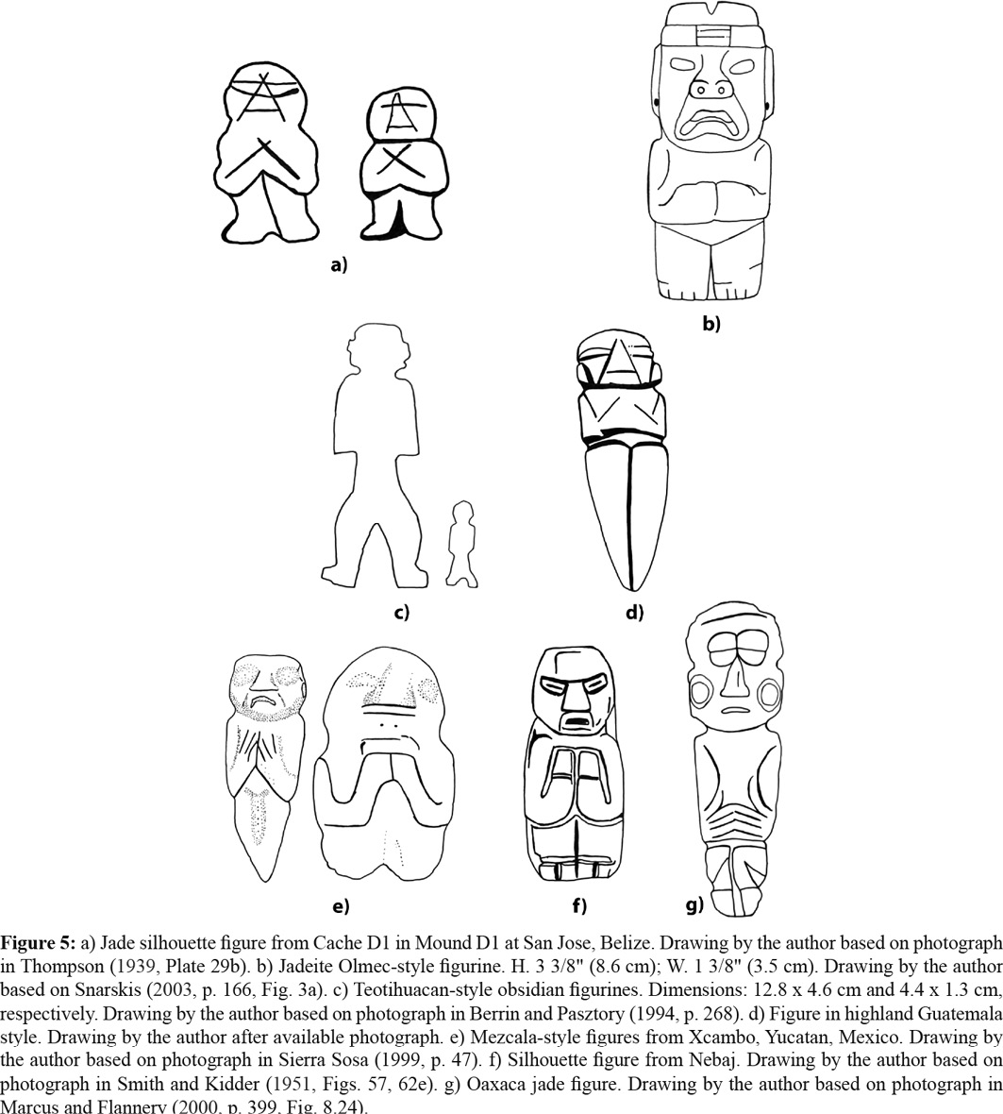

Drawing by David F. Mora-Marín, UNC, Chapel Hill, NC.

The Lowland Maya Versions

In the Maya area the CCFT is characterized by two variants: (1) a silhouette CCFT figure in a standing pose with legs bent to the sides, and arms bent upward toward the chest; (2) a silhouette CCFT figure in a sitting pose with crossed legs, arms bent upward toward the chest; and (3) on some occasions, the CCFT figure is with closed eyes. Different poses of the arms are also known, such as the two arms bent sideways toward the waist with the fingers of both hands touching. Thompson ([1931](https://revistas.ucr.ac.cr/index.php/antropologia/article/view/25274/25732" \l "Thompson--J.-E.-S.--1931-), [1939](https://revistas.ucr.ac.cr/index.php/antropologia/article/view/25274/25732" \l "Thompson--J.-E.-S.--1939-)) discussed a variety of CCFT figures from the Maya lowlands. Additional CCFT examples are seen in Figure 6a-c; the example in Figure 6b, recovered from the Sacred Cenote of Chichen Itza, and argued by [Coggins (1984)](https://revistas.ucr.ac.cr/index.php/antropologia/article/view/25274/25732" \l "Coggins--C.-C.--1984-) to be a Late Preclassic version of a Mayan CCFT, could instead be an actual Costa Rican example, given the drilling of the eyes and incising of the nose, consistent with the Costa Rican versions, a suggestion first made to by John Hoopes (personal communication, 2014) that I support and elaborate upon below. [Taschek and Ball (1999)](https://revistas.ucr.ac.cr/index.php/antropologia/article/view/25274/25732" \l "Taschek--J.-T.-and-Ball--J.-W.--1999-) have discussed their presence at the site of Arenal in Belize. Whenever they are found in Late Classic contexts they are considered to be examples of heirlooms, as with several Copan-style jades described by [Easby (1993)](https://revistas.ucr.ac.cr/index.php/antropologia/article/view/25274/25732" \l "Easby--E.-K.--1993-).

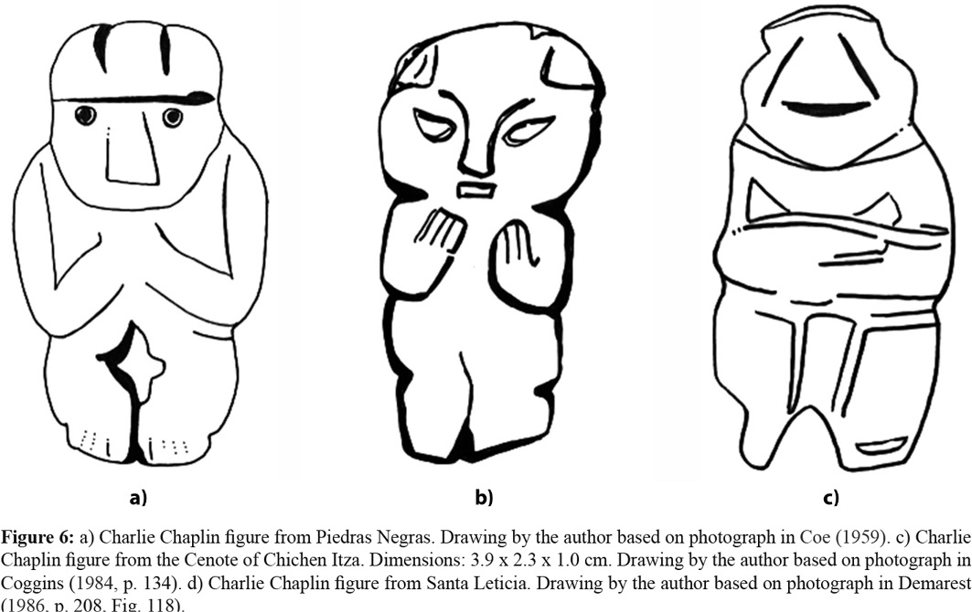

 Drawing by David F. Mora-Marín, UNC, Chapel Hill, NC.

Copan developed its own style of CCFT figures, as seen in Figure 7, which shows both standing (Figure 7a-7b) and seated versions (Figure 7c-7d). The seated CCFT versions, such as a famous example from Uaxactun, sometimes exhibit closed eyes (Figure 7d).

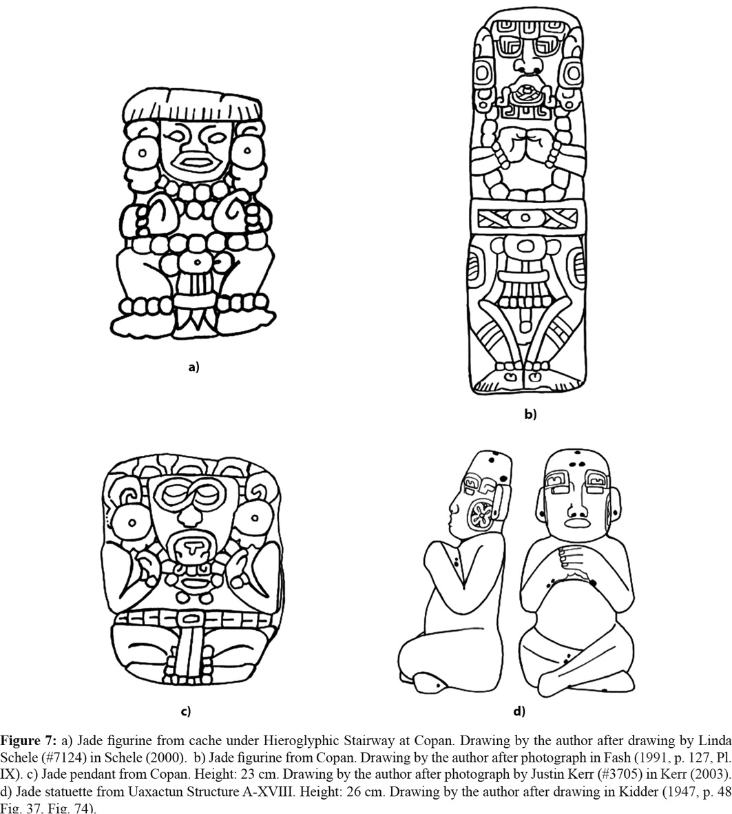

Drawing by David F. Mora-Marín, UNC, Chapel Hill, NC.

This pan-Mesoamerican perspective for the study of CCFT pendants supports a thematic and stylistic connection. For example, CCFT silhouettes suggest a relationship to figures such as the Cache 1 (Structure 6B) head pendants from Cerros, Belize ([Freidel and Schele, 1988](https://revistas.ucr.ac.cr/index.php/antropologia/article/view/25274/25732" \l "Freidel--D.-and-Schele--L.--1988-); [Garber, 1981](https://revistas.ucr.ac.cr/index.php/antropologia/article/view/25274/25732" \l "Garber--J.-F.--1981-)), a figurine from Santa Leticia, Figure 8a, Chalchuapa and Quelepa (Demarest [1986](https://revistas.ucr.ac.cr/index.php/antropologia/article/view/25274/25732" \l "Demarest--A.--1986-), p. 208-209, Fig. 118). The Quelepa examples by Andrews ([1976](https://revistas.ucr.ac.cr/index.php/antropologia/article/view/25274/25732" \l "Andrews-V.--E.-Wyllys-V.--1976-), p. 167-168, Fig. 172), however, are not full-figure forms, but simply the heads, as seen in Figure 8b, indicating the practice of part-for-the-whole substitution. In fact, referring to a Late Preclassic-style figure pendant with a biconical horizontal suspension hole from the Cenote of Chichen Itza, seen in Figure 8c, Coggins ([1984](https://revistas.ucr.ac.cr/index.php/antropologia/article/view/25274/25732" \l "Coggins--C.-C.--1984-)) not only notes a similarity with the CCFT figures and shell figures from southern lowlands identified by [Thompson (1939)](https://revistas.ucr.ac.cr/index.php/antropologia/article/view/25274/25732" \l "Thompson--J.-E.-S.--1939-), but also adds that like the bib-helmet head pendant also found at the Cenote ([Coggins, 1984](https://revistas.ucr.ac.cr/index.php/antropologia/article/view/25274/25732" \l "Coggins--C.-C.--1984-), p. 135), this figure’s nose is “a triangle with the mouth serving as its base, and the pupils of the eyes are drilled,” common Late Preclassic traits, such as the ones from Cerros, as seen in Figure 8d.

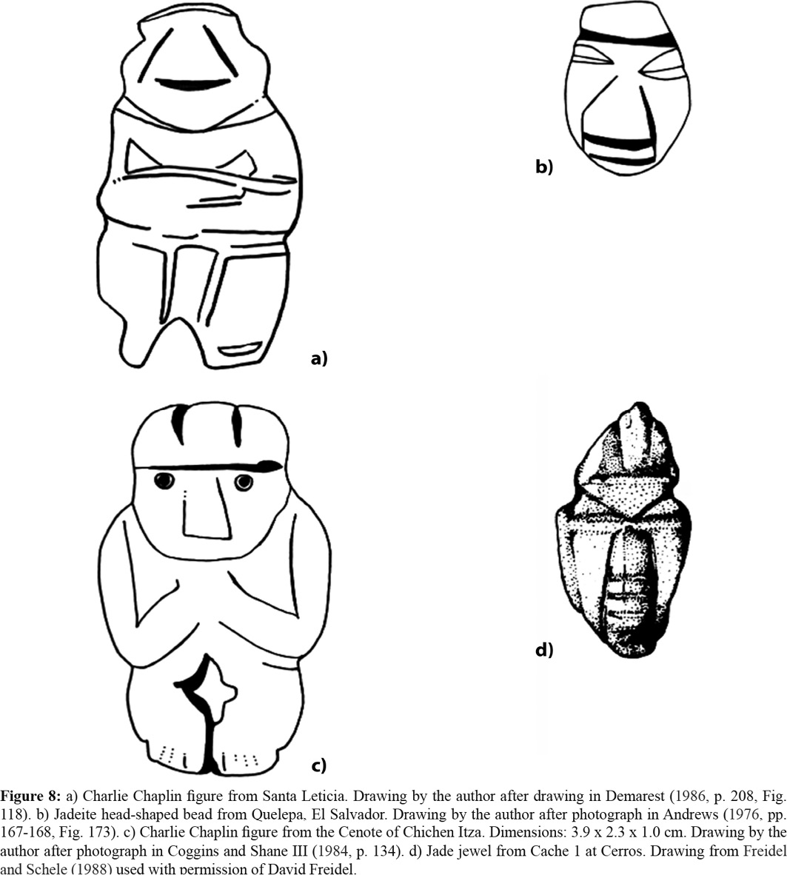

Nevertheless, the Cenote CCFT most closely resembles the Costa Rican counterparts in the way the eyes are drilled, as well as the rhomboidal drilling used to separate the legs, as observed by Hoopes (personal communication, 2014). The transverse bi-conical drilling on the piece, as a means for suspension of the pendant, is also more characteristic of the Costa Rican lapidary’s version of this theme. Interestingly, the form and style of the head of this figure is not only similar to the bipartite helmet-crown of Late Pre-classic head pendants, but also to the head pendant that served as the central axis of Cache 1 at Cerros, as compared in Figure 9a and 9b; both show a tripartite crown, although stylistically they differ in the eyes and mouth. This Cenote example of a Costa Rican-style CCFT suggests a diffusion into Mayan territory.

The part-for-the-whole relationship is evinced elsewhere, just like the Cerros Cache 1 bipartite-helmet and central head pendants are arranged in a quincunx pattern, as in Figure 9c, two caches at the site of Arenal in Belize ([Taschek and Ball, 1999](https://revistas.ucr.ac.cr/index.php/antropologia/article/view/25274/25732" \l "Taschek--J.-T.-and-Ball--J.-W.--1999-)) contain full-figure CCFT silhouettes also arranged in quincunx patterns, as in Figure 9d. In other words, the head and full-figure pendants are equivalent. The derivation of new sign-forms in Mayan hieroglyphic writing often associates the part (e.g. the head of the ruler) was used to stand for the whole (i.e. ruler).

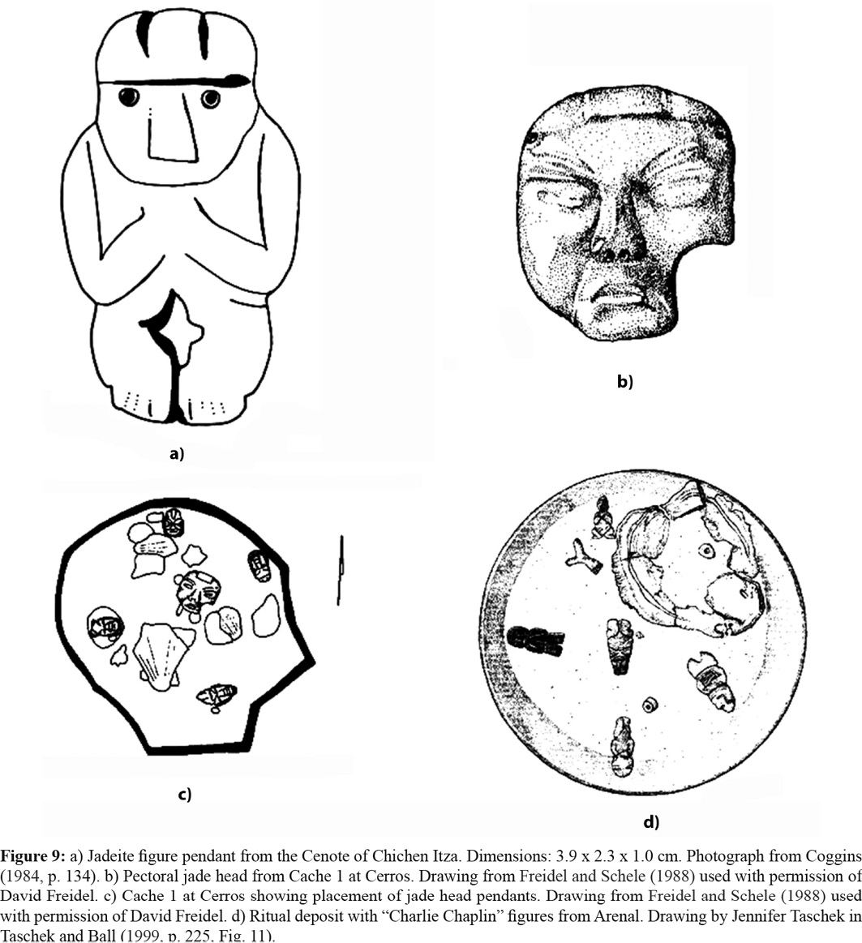

The Costa Rican Version

Unfortunately, only one specimen of a CCFT jade pendant is known from archaeological contexts in Costa Rica: it is the example from the site of Mercocha, in the Atlantic Watershed, excavated by [Stirling (1969)](https://revistas.ucr.ac.cr/index.php/antropologia/article/view/25274/25732" \l "Stirling--M.-W.--1969-), which was radiocarbon dated to ca. A.D. 144 (A.D. 103-545). All other known examples lack contextual data, and thus, it is not possible at present to describe their chronological distribution within Costa Rica. However, they are clearly carved following the norms of the Costa Rican lapidary, including the transverse perforation for suspension at the base of the neck, and in some cases the addition of Costa Rican motifs, such as double-headed zoomorphs on top of the figure’s head, and female features. Balser ([1961](https://revistas.ucr.ac.cr/index.php/antropologia/article/view/25274/25732" \l "Balser--C.--1961-), p. 213, Figs. 1b-c) first defined this theme as the Atlantic Watershed version of the Nicoya-style anthropomorphic Axe-God, adding that, as one of its diagnostic traits, the “Arms with well-marked fingers always point upward.” One example is seen in Figure 10.

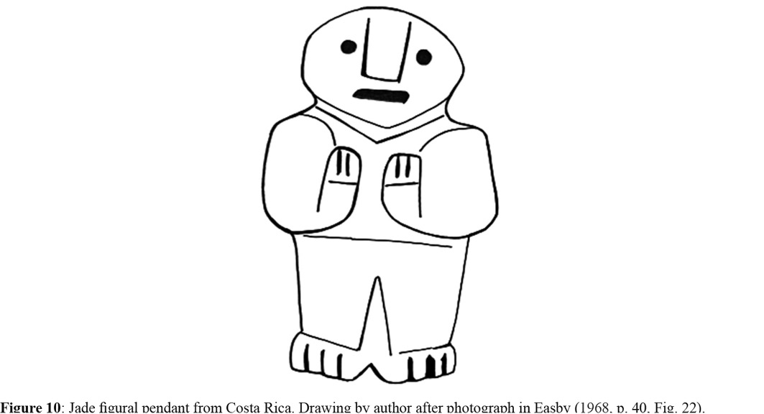

Drawing by David F. Mora-Marín, UNC, Chapel Hill, NC.

Like the Maya version, the Costa Rican CCFT version comes in two general varieties: (1) a standing form, and (2) a seated form. And like the Mayan CCFT versions, the nose is either triangular or rectangular, but it is quite prominent. The standing form is the more common of the two. Unlike the Mesoamerican versions, the Costa Rican version consistently shows gender variation: the figures may be male (Figure 11a-b and 11d, f) or female (Figure 11c, e). It is possible that the Mezcala-style versions may occasionally show female forms reaffirming the fact that among indigenous Costa Ricans both women and men could be healers; in the Mayan case, though, healers were predominantly men, although midwives, by definition a type of healer, were women. Also, the CCFT figures may be plain, or elaborated with Costa Rican motifs, such as the Double-Tuft Motif, the Double-Headed Crest Motif, and Trophy-Head Hands Motif, and the Sideways-Pointing Zoomorphic Feet Motif. More commonly, as with their Mesoamerican counterparts, the hands are raised or level, and they may meet or remain separated. Like some of the Mayan examples, a few Costa Rican CCFT specimens show bent legs (Figure 11c-d); in such instances, a rhomboidal opening separates the legs, as with the Cenote example discussed above (Figures 6b, 8c, 9a).

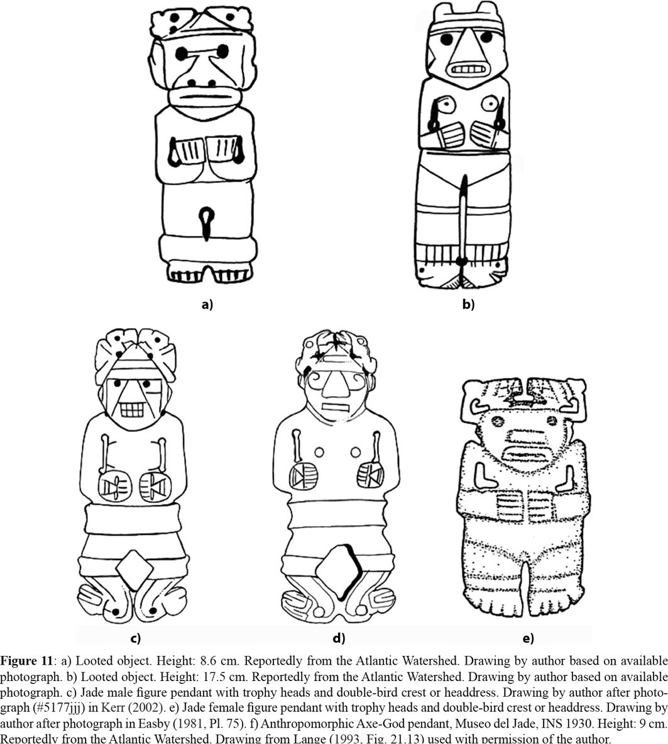

The seated form is less common. Like the CCFT standing form, the seated CCFT form exhibits gender variation: at least one example is female (Figure 12a), and at least one example is male (Figure 12b). Interestingly, there may be a relationship between the seated form of the CCFT (Figure 12c) and the Frog Theme (Figure 12d), as suggested by the shape of the crossed legs. Costa Ricans modified the Ritual CCFT further, by combining it with a previously existing theme, the AvAGT.

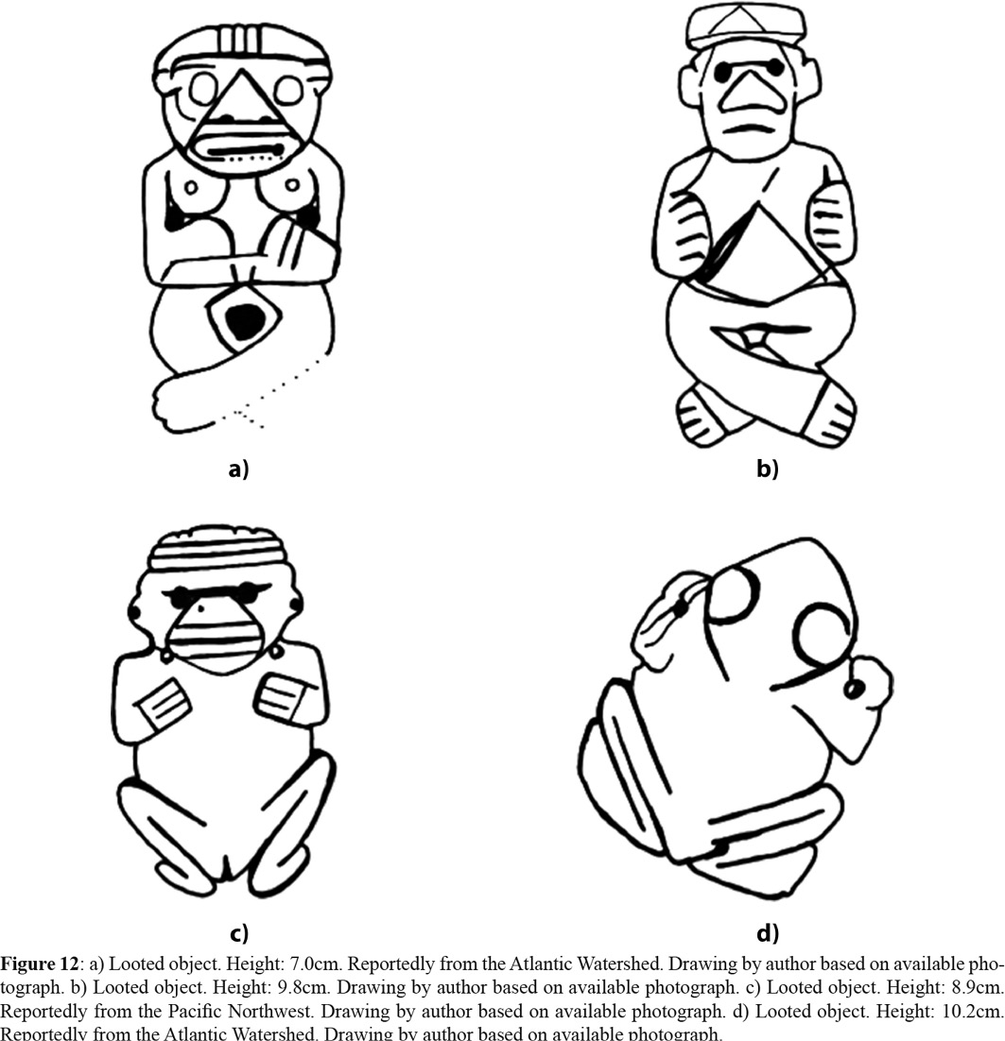

Drawing by David F. Mora-Marín, UNC, Chapel Hill, NC.

 Diffusion: Adoption, Adaptation

It would appear that the ancient artisans of Costa Rica borrowed the CCFT from Mesoamerica, likely from the Lowland Mayans. The Mesoamerican form predates the Costa Rican form by several centuries, given the Middle Formative Olmec precedents, while the earliest, archaeologically contextualized example from Costa Rica dates to 144 CE (A.D. 103-545). The triangular nose, the slightly incised eyes, the characteristic arm postures (raised or straight), the bent legs, and the variation between standing and seated postures are all shared attributes (Figure 13). The sideways-pointing feet and bent knees are characteristics that occur together (optionally), to my knowledge, only in the Mayan and Costa Rican versions, and suggest a close relationship, making it likely that the ancient artisans from Costa Rica developed their version through contact with the Mayans in particular, not any other Mesoamerican group.

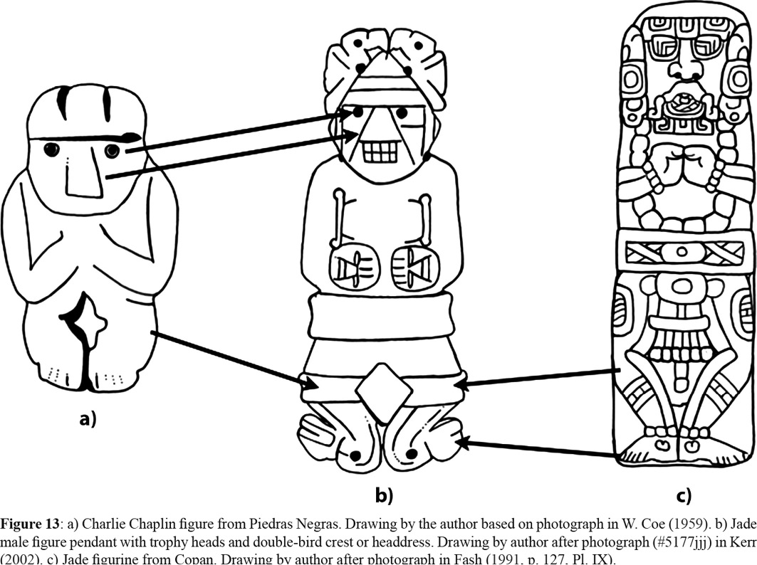

Drawing by David F. Mora-Marín, UNC, Chapel Hill, NC.

But as already noted, the ancient artisans from Costa Rica did not simply adopt this theme. They adapted it to their own artistic and iconographic canons. There was, in essence, a process of “stylistic translation,” exhibited by the preference for transverse perforations for suspension, typical of the Costa Rican jade lapidary tradition. And there was a process of “iconographic adaptation,” exhibited by the addition of uniquely Costa Rican motifs, such as the Double-Tuft Motif, the Double-Headed Zoomorphic Crest Motif, the Trophy-Head Hands Motif, and the Sideways-Pointing Zoomorphic Feet Motif.

More interesting, perhaps, is the evidence for the development of an entirely new set of related themes: AvAGT, the Ritual AAGT (RAAGT), and the AAGT. At this point, the chronology is clear only in one respect: the AvAGT, attested as early as 500 B.C. at the site of La Regla, that precedes the other two by centuries. What is not yet clear is the chronology of the RAAGT and the AAGT, as already noted, given the lack of precision of the radiocarbon date for the RAAGT pendant form the Mercocha site, and the potentially questionable dating of the AAGT pendants from Loma Corral. Another point that appears to be clear is this: RAAGT theme is likely Mesoamerican in origin.

If the Costa Rican version of the RAAGT predates the AAGT, then an interesting possibility emerges: perhaps the AvAGT and the RAAGT underwent cultural fusion, resulting in the AAGT. It is possible that a transition from the figural to the axe-shaped forms, as proposed by the illustration in Figure 14. As already mentioned, the Mercocha example (Figure 13a), and other similar examples, exhibit a set of legs that seem to show a rough axe-blade outline, as suggested by the curved toe-line of the feet. Perhaps this development continued until an axe-blade, a motif taken from the AvAGT, enveloped the legs (Figure 13b), followed by the disappearance of the legs (Figure 13c), a development attested in the Severo Ledesma example two centuries or so later. Again, the triangular nose, the oval-shaped mouth, the optional double-tufted or double-headed crest, and the position of the arms are clearly transmitted from the figural to the Axe-God jade pendants. This model of course relies on the currently available chronological information, and future archaeological work is required to test it.

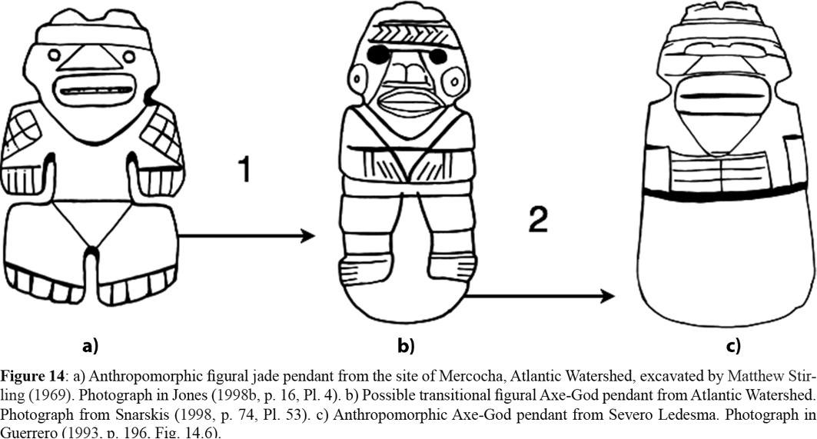

A similar development may have taken place with the seated versions of the RAAGT (Figure 15a); nevertheless, no reliable chronological data exist to support this scenario, and it is thus based entirely on its possible parallel with the scenario presented above for the standing versions of the RAAGT These also appear to have developed a blade that engulfed the legs (Figure 15b), followed by a process in which the legs and blade were fully differentiated, leaving only the blade (Figure 15c). After this development, these two anthropomorphic themes co-existed until the cessation of the jade lapidary tradition.

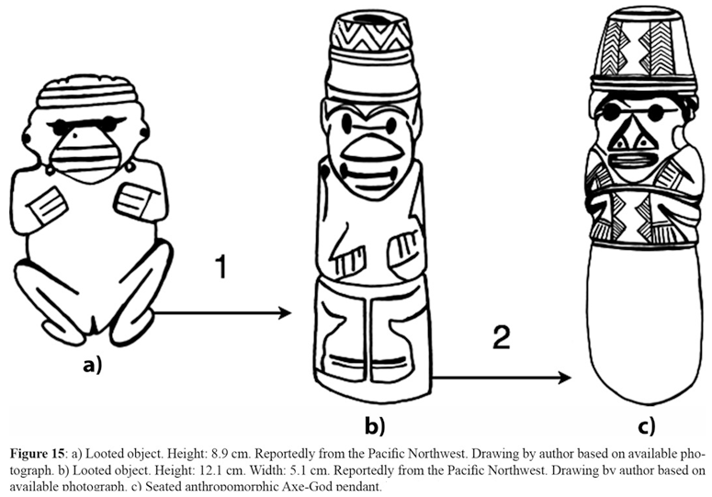

Drawing by David F. Mora-Marín, UNC, Chapel Hill, NC.

Another possibility is that the AAGT preceded the RAAGT. If this is a valid scenario, perhaps by only a century or two, then the situation would be different. Perhaps the artisans from Costa Rica innovated the AAGT by analogy with the AvAGT, and subsequently, they adopted the RAAGT from Mesoamerica, but adapted it by incorporating stylistic traits and motifs that were already part of the emerging AAGT. In either scenario, the RAAGT is a product of diffusion.

Origins of the RAAGT: The Axi Mundi Theme

The CCFT may have originated in Olmec ritual art during the Middle Preclassic period. More specifically, its origin may lie in the pose identified by [Reilly (1990)](https://revistas.ucr.ac.cr/index.php/antropologia/article/view/25274/25732" \l "Reilly--K.--1990-) as signaling the establishment of the “Axis Mundi”, wherein the religious specialist identifies himself with the World Tree, and as a conduit of communication between cosmic realms. As seen in Figure 16a, such pose is comparable to that of the typical CCFT figure, if one simply deletes the ceremonial bar held in the arms. For while David Freidel (personal communication, 2005) has suggested that the “crab-claw” pose “is demonstrably the pose of cradling the ‘ceremonial bar’,” It is possible that the CCFT pose itself came first, potentially as a preexisting gesture or sign referring to a ritual action, and was retained conventionally whenever the bearing of the so-called ceremonial bar was incorporated ritually. In Figure 16b one can see a part-for-the-whole version of this pose and its components in two instances of Olmec art from the Middle Formative period (1000-400 B.C.). Such pose was later assumed by Maya rulers, who identified themselves with the World Tree, portraying themselves with the typical CCFT pose while holding a ceremonial bar and wearing jade celts or plaques, as seen in many Classic-period stelae, such as Naranjo Stela 6 ([Graham, 1978](https://revistas.ucr.ac.cr/index.php/antropologia/article/view/25274/25732" \l "Graham--I.--1978-)).

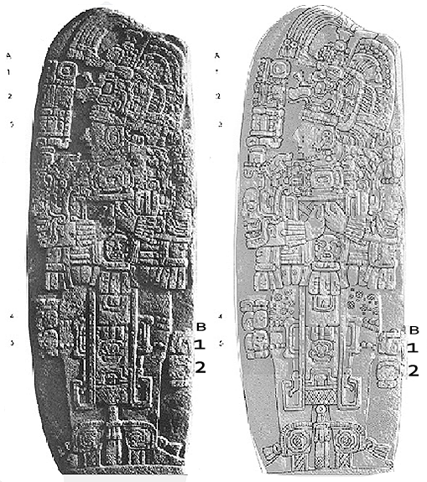

Fig. 16 a-b. Naranjo Limestone Stela 6 (H 1.69 m) with glyphs numbered A 1-5 , B 1-2. (After https://www.peabody.harvard.edu/cmhi/flash/detailview.swf?num=6&site=Naranjo&type=Stela

T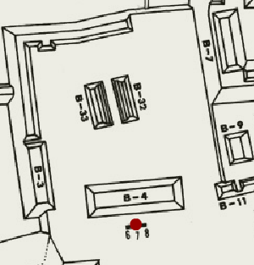he Naranjo Limestone Stela 6 is the Westernmost of three stelae set on the south side of Structure B-4. Maler found it lying on its face, which was very well preserved while the back, exposed to weathering, was badly eroded when discovered. In 1964 the front surface was split off and went into private ownership in Chicago. The splitting of the stela resulted in destruction 1) of column F of the inscription, 2) adjacent glyphs, and 3) the upper right-hand corner of the front surface. The front surface has lost its pristine condition and has been cut into three pieces with a saw. The drawing of the front is based on Maler's 1905 photograph and the original front surface. The back surface has been traced from a rectified print of Morley's 1914 oblique photograph, with details from this and from a field drawing.

Fig 16 c. The placement of the Naranjo limestone stela 6 in front of the structure B-4 on the map of the “Ruins of Naranjo.” After https://www.peabody.harvard.edu/cmhi/flash/mapview.swf?newXpos=946&newYpos=856&site=Naranjo

The four celts that Reilly proposes to be in a quadripartite arrangement about the ruler in the Arroyo Pesquero celts can be seen as belt-celt trios arranged about the ruler’s waist on the Maya counterpart, assuming the presence of a fourth belt-celt trio behind the ruler.

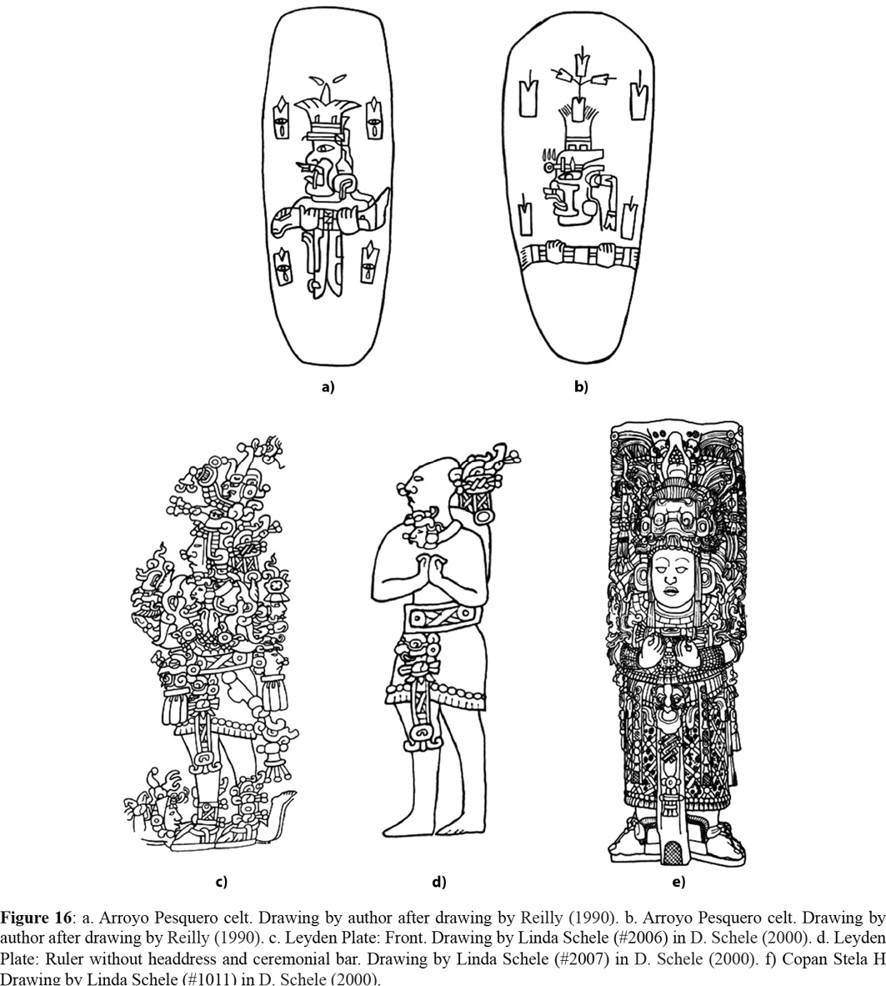

A comparable example of the CCFT is in the Early Classic Leyden Plate, seen in Figure 16c (Schele and Miller [1986](https://revistas.ucr.ac.cr/index.php/antropologia/article/view/25274/25732" \l "Schele--L.-and-Miller--M.--1986-), pp. 120-121). Once stripped of its headdress and ceremonial bar through extrapolation, as in Figure 16d, it is clear that the personage depicted exhibits the characteristic stance of CCFT figures. It is this stance that characterized the Early Classic royal portraiture on jade plaques and stelae (Mathews, 1985; [Fields, 1989](https://revistas.ucr.ac.cr/index.php/antropologia/article/view/25274/25732" \l "Fields--V.-M.--1989-)), although at some sites, such as at Naranjo and Copan, this conventional theme persisted well into the Late Classic, as in Figure 16f. Consequently, the figural theme of the CCFT figures is not an isolated theme, but instead, the basic template of the Ruler-as-Axis Mundi, with minimum details to establish the Axis Mundi. The portraits present on the Leyden Plate and Early Classic stelae depict the ruler, engaged in ritual action.

The scale of the CCFT artifacts differS according to their utility ranging from large, monumental scale stela with iconographic details for public display to diminutive scale artifacts with abbreviated or omitted iconographic details for use as personal adornments or for deposit in ritual areas as in Belize. Furthermore, these iconographic representations of the CCFT were condensed on variety of media: jadeite and other greenstones, obsidian, shell, wood, stelae and rock art.

**References:**

Andrews V., E. Wyllys V. 1976. The Archaeology of Quelepa, El Salvador. New Orleans: Middle American Research Institute Publication 42, Tulane University.

Andrews V., E. Wyllys V. April 1986a. Olmec Jades and Early Maya Pottery. Paper presented at the Recent Archaeological Research in the Northern Maya Lowlands Symposium of the 51st Annual Meeting of the Society for American Archaeology. New Orleans, Lousiana.

Andrews V., E. Wyllys V. 1986b. Olmec Jades from Chacsinkin, Yucatan, and Maya Ceramics from La Venta, Tabasco. In E. W. Andrews V. (ed.), Research and Reflections in Archaeology and History: Essays in Honor of Doris Stone (pp. 11-49). New Orleans: Middle American Research Institute, Publication 57, Tulane University Press.

Andrews V., E. Wyllys V. 1987. A Cache of Early Jades from Chaksinkin, Yucatan. Mexicon, 9(4), 78-85.

Balse. El jade precolombino de Costa Rica. San José: Libreria e Imprenta Lehmann.

Balser, C. 1958. Los “Baby Faces” Olmecas de Costa Rica. Proceedings, 33rd International Congress of Americanists, San Jose, Costa Rica.

Balser, C. 1961. Some Costa Rican Jade Motifs. In S. K. Lothrop and J. I. Kislak (eds), Essays in Pre-Columbian Art and Archaeology (pp. 210-265). Cambridge, Massachussetts: Harvard University Press.

Balser, C. 1968. Metal and Jade in Lower Central America. In D. Stone (coord.), Actas y Memorias, XXXVII Congreso Internacional Americanista (Vol. 4, pp. 57-63). Buenos Aires: Librart.

Balser, C. 1969. A New Style of Olmec Jade with String Sawing from Costa Rica. Verhandlungen des XXXVIII Internationalen Amerikanistenkongresses Kongresses (Vol. 1, pp. 243-247). Munich: Kommissionsverlag Klaus Renner.

Balser, C. 1974. El Jade de Costa Rica. San José: Libreria e Imprenta Lehmann.

Balser, C. 1980. El jade precolombino de Costa Rica. San José: Litografia e Imprenta LIL, S.A.

Berrin, K. and Pasztory, E. 1994. Teotihuacan: Art from the City of the Gods. New York: Thames and Hudson.

Bishop, R. L. and Lange, F. W.1993). Sources of Maya and Central American Jadeitites: Data Bases and Interpretations–A Summary. In F. W. Lange (ed.), Precolumbian Jade: New Geological and Cultural Interpretations (pp. 125-130). Salt Lake City: University of Utah Press.

Bishop, R. L., Sayre, E. V. and Mishara, J. 1985. Characterization of Mesoamerican Jade. In P. A. England and L. van Zelst (eds), Application of Science in Examination of Works of Art (pp. 151-156). Boston: The Research Laboratory, Museum of Fine Arts.

Bishop, R. L., Sayre, E. V. and Mishara, J. 1993. Compositional and Structural Characterization of Maya and Costa Rican Jadeites. In F. W. Lange (ed.), Precolumbian Jade: New Geological and Cultural Interpretations (pp. 30-60). Salt Lake City: University of Utah Press.

Bray, W. 2003. Gold, Stone, and Ideology: Symbols of Power in the Tairona Tradition of Northern Colombia. In J. Quilter and J. W. Hoopes (eds), Gold and Power in Ancient Costa Rica, Panama, and Colombia (pp. 301-344). Washington, D.C.: Dumbarton Oaks Research Library and Collection.

Calvo, M., Bonilla, L. and Sánchez, J. 1992. Oro, jade, boques: Costa Rica. San José: FISA—Escudo de Oro, S.A.

Caso, A. 1965. Lapidary Work, Goldwork, and Copperwork from Oaxaca. In R. Wauchope (ed.), Handbook of Middle American Indians (Vol. 3, pp. 896-930). Austin: University of Texas Press.

Chenault, M. L. 1986. Technical Analysis of Precolumbian Costa Rican Jadeite and Greenstone Artifacts (Unpublished master’s thesis). University of Colorado, Boulder, United States of America.

Chenault, M. L. 1988. Jadeite, Greenstone, and the Precolumbian Costa Rican Lapidary. In F. W. Lange (ed.), Costa Rican Art and Archaeology, Essays in Honor of Frederick R. Mayer (pp. 91-109). Colorado: Johnson Pub.

Coe, M. D. 1965. The Olmec Style and its Distribution. In G. Willey (ed.), Handbook of Middle American Indians (Vol. 3, pp. 739-775). Austin: University of Texas Press.

Coe, W. R. 1959. Piedras Negras Archaeology: Artifacts, Caches, and Burials. Philadelphia: University of Pennsylvania, University Museum.

Coggins, C. C. 1984. The Cenote of Sacrifice: Catalogue. In C. C. Coggins and O. C. Shane III (eds), Cenote of Sacrifice: Maya Treasures from the Sacred Well at Chichén Itzá (pp. 23-166). Austin: University of Texas Press.

Coggins, C. C., and Shane, O. C. III (eds). 1984. Cenote of Sacrifice; Maya Treasures from the Sacred Well at Chichén Itzá. Austin: University of Texas Press.

Covarrubias, M. 1942. Origen y desarrollo del estilo artístico “Olmeca”, In Sociedad Mexicana de Antropología (eds), Mayas y Olmecas: Segunda Reunión de Mesa Redonda Sobre Problemas Antropológicos de México y Centro América (pp. 46-49). Mexico D.F.: Sociedad Mexicana de Antropología.

Covarrubias, M. 1946. El arte “Olmeca” o de La Venta. Cuadernos Americanos, 28(4), 153-179.

Covarrubias, M. 1957. Indian Art of Mexico and Central America. New York: Knopf.

Day, J. S. 1993. The Media of Ritual. In F. W. Lange (ed.), Precolumbian Jade: New Geological and Cultural Interpretations (pp. 289-306). Salt Lake City: University of Utah Press.

Day, J. S. and Tillet, A. C. 1996. The Nicoya Shaman. In F. W. Lange (ed.), Paths to Central American Prehistory (pp. 221-235). Niwot, Colorado: University of Colorado.

Demarest, A. 1986. The Archaeology of Santa Leticia and the Rise of Maya Civilization. New Orleans: Middle American Research Institute Publication 52, Tulane University.

Digby, A. 1964. Maya Jades. London: Trustees of the British Museum.

Easby, E. K. 1963. Un “Dios-Hacha” de las tierras altas Mayas. Estudios de Cultura Maya, 3, 97-106.

Easby, E. K. 1968. Pre-Columbian Jade of Costa Rica. New York: André Emmerich.

Easby, E. K. 1981. Jade. In E. P. Benson (ed.), Between Continents/Between Seas: Precolumbian Art of Costa Rica (pp. 135-155). New York: Harry N. Abrams, Inc.

Easby, E. K. 1993. The Beginning of Classic Maya Jade Carving in the Southeast. In F. W. Lange (ed.). Precolumbian Jade: New Geological and Cultural Interpretations (pp. 133-148). Salt Lake City: University of Utah Press.

Fash, W. 1991. Scribes, Warriors and Kings: The City of Copán and the Ancient Maya. New York: Thames and Hudson.

Fields, V. M. 1989. The Origins of Divine Kingship among the Lowland Classic Maya (Unpublished doctoral dissertation). University of Texas at Austin, Texas, United States of America.

Fields, V. M. and Reents-Budet, D. J. 1992. Historical Implications of the Jade Trade between the Maya Lowlands and Costa Rica during the Early Classic Period. In S. Markel (ed.), World of Jade (pp. 81-88). Bombay: Marg Publications.

Freidel, D. and Schele, L. 1988. Kingship in the Late Preclassic Maya lowlands: The Instruments and Places of Ritual Power. American Anthropologist, 90(3), 547-567.

Freidel, D., Schele, L. and Parker, J. 1993. Maya Cosmos. Three Thousand Years on the Shaman’s Path. New York: Quill William Morrow.

Garber, J. F. 1981. Patterns of Jade Consumption and Disposal at Cerros, Northern Belize. American Antiquity, 48, 800-807.

Garber, J. F., Grove, D. C., Hirth, K. G. and Hoopes, J. W. 1993. Jade Use in Portions of Mexico and Central America. In F. W. Lange (ed.), Precolumbian Jade: New Geological and Cultural Interpretations (pp. 211-231). Salt Lake City: University of Utah Press.

Gay, C. T. E. 1967. Mezcala Stone Sculpture: The Human Figure (Museum of Primitive Art. Studies No. 5). New York: Museum of Primitive Art.

Gay, C. T. E. 1987. Mezcala architecture in miniature. Brussels: Palais des Academies.

Gendron, F., Smith, D. C. and Gendron-Badou, A. 2002. Discovery of Jadeite-Jade in Guatemala Confirmed by Non-Destructive Raman Microscopy. Journal of Archaeological Science, 29(8), 837-851.

Graham, I. 1978. Corpus of Maya Hieroglyphic Inscriptions (Vol. 2, Part 2: Naranjo). Cambridge: Peabody Museum of Archaeology and Ethnology.

Graham, M. M. 1993. Displacing the Center: Constructing Prehistory in Central America. In M. Miller (ed.), Reinterpreting Prehistory of Central America (pp. 1-38). Niwot, Colorado: University of Colorado Press.

Graham, M. M. 1998. Mesoamerican Jade and Costa Rica. In J. Jones (ed.), Jade in Ancient Costa Rica (pp. 39-57). New York: The Metropolitan Museum of Art.

Griffin, G. G. 1993. Formative Guerrero and its Jade. In F. W. Lange (ed.), Precolumbian Jade: New Geological and Cultural Interpretations (pp. 203-210). Salt Lake City: University of Utah Press.

Guerrero, J. V. 1986. El contexto del jade en Costa Rica. Vínculos, 12(1-2), 171-188.

Guerrero, J. V. 1993. The Context of Jade in Costa Rica. In F. W. Lange (ed.), Precolumbian Jade: New Geological and Cultural Interpretations (pp. 191-202). Salt Lake City: University of Utah Press.

Guerrero, J. V. 1998. The Archaeological Context of Jade in Costa Rica. In J. Jones (ed.), Jade in Ancient Costa Rica (pp. 23-37). New York: The Metropolitan Museum of Art.

Guerrero, J. V., Solís, F. and Vásquez, R. 1994. El Período Bagaces (300-800 d.C.) en la cronología arqueológica del noroeste de Costa Rica. Vínculos, 18-19(1-2), 91-109.

Guerrero, J. V., Solís, F. and Solano, F. 1992. Entierros secundarios y restos orgánicos de ca. 500 a.C. preservados en un área de inundación marina, Golfo de Nicoya, Costa Rica. Vínculos, 17(1-2), 17-52.

Hardy, E. T. 1992. The Mortuary Behavior of Guanacaste/Nicoya: An Analysis of Pre-Columbian Social Structure. PhD Dissertation.

Harlow, G. E. 1993. Middle American Jade: Geologic and Petrologic Perspectives on Variability and Source. In F. W. Lange (ed.), Precolumbian Jade: New Geological and Cultural Interpretations (pp. 9-29). Salt Lake City: University of Utah Press.

Hartman, C. V. 1907. Archaeological Researches on the Pacific Coast of Costa Rica (Memoirs of the Carnegie Museum, No. 3). Pittsburgh: Carnegie Museum.

Hirth, K. and Grant S. 1993. Ancient Currency: The. Style and Use of Jade and Marble Carvings in Central Honduras. In F. W. Lange (ed.), Pre-Columbian Jade (pp. 173-190). Salt Lake City: University of Utah Press.

Hoopes, J. W. 1985. Trade and Exchange. In G. R. Willey and P. Mathews (eds), A Consideration of the Early Classic Period in the Maya Lowlands (pp. 145-160). Albany: Institute for Mesoamerican Studies, State University of New York at Albany.

Hoopes, J. W. 1991. The Isthmian Alternative: Reconstructing Patterns of Social Organization in Formative Costa Rica. In W. R. Fowler, Jr. (ed.), The Formation of Complex Society in Southeastern Mesoamerica (pp. 171-192). Boca Raton, Florida: CRC Press.

Hoopes, J. W. 2001. Race, Language, and Culture in the Intermediate Area: Recovering Chibchan Identities from the Mid-Hemispheric “Periphery”. 100th Annual Meeting of the AAA. Washington D.C.

Hoopes, J. W. 2005. The Emergence of Social Complexity in the Chibchan World of Southern Central America and Northern Colombia, AD 300–600. Journal of Archaeological Research, 13(1), 1-47.

Hoopes, J. W. 2012. Culturas chibchas del citoral Caribe: Explorando conexiones precolombinas entre Colombia y Costa Rica. In C. Gnecco y V. González (eds), La Arqueología del Area Intermedia (pp. 367-412). Bogotá: Instituto Colombiano de Antropología e Historia.

Hoopes, J. W. and Fonseca, O. M. 2003. Goldwork and Chibchan Identity: Endogenous Change and Diffuse Unity in the Isthmo-Colombian Area. In J. Quilter and J. W. Hoopes (eds), Gold and Power in Ancient Costa Rica, Panama, and Colombia (pp. 49-89). Washington, D.C.: Dumbarton Oaks Research Library and Collection.

Jones, J. (ed.). 1998a. Jade in Ancient Costa Rica. New York: The Metropolitan Museum of Art.

Jones, J. 1998b. Introduction. In J. Jones (ed.), Jade in Ancient Costa Rica (pp. 11-22). New York: The Metropolitan Museum of Art.

Kerr, J. 2002. Figural Pendant. A Precolumbian Portfolio: An Archive of Photographs. Retrieved from [http://research.mayavase.com/portfolio_hires.php?search=5177jjj&date_added=&image=5177jjj&display=8&rowstart=0](http://research.mayavase.com/portfolio_hires.php%3Fsearch%3D5177jjj%26date_added%3D%26image%3D5177jjj%26display%3D8%26rowstart%3D0)

Kerr, J. 2003. Maya Jade Pendant. A Precolumbian Portfolio: An Archive of Photographs. Retrieved from [http://research.mayavase.com/portfolio_hires.php?search=3705&date_added=&image=3705&display=8&rowstart=0](http://research.mayavase.com/portfolio_hires.php%3Fsearch%3D3705%26date_added%3D%26image%3D3705%26display%3D8%26rowstart%3D0)

Kidder, A. V. 1947. The Artifacts of Uaxactun, Guatemala (Carnegie Institution of Washington Publication 576). Washington D.C.: Carnegie Institution of Washington.

Kidder, A. V. 1949. Certain Archaeological Specifimens from Guatemala (Notes on Middle American Archaeology and Ethnology, Publication 92). Washington D.C.: Carnegie Institution of Washington.

Kidder, A. V. 1951. Excavations at Nebaj, Guatemala (Publication, 594). Washington, D.C.: Carnegie Institution of Washington.

Kirchhoff, P. 1943. Mesoamérica: Sus límites geográficos, composición étnica y caracteres culturales. Acta Americana, 1, 92-107.

Lange, F. W. 1986. Central America and the Southwest: A Comparison of Mesoaemrica’s Two Peripheries. In E. W. Andrews (ed.), Research and Reflections in Archaeology and History: Essays in Honor of Doris Stone (American Research Institute, Publication 57), (pp. 159-177). New Orleans: Tulane University Middle.

Lange, F. W. 1984. Elite Participation in Precolumbian Ceramic Transfer in Costa Rica. In E. Skirboll and W. Creamer (ed.), Inter-Regional Ties in Costa Rican Prehistory (pp. 143-178). Oxford, England: B.A.R.

Lange, F. W. 1993. Formal Classification of Prehistoric Costa Rican Jade: A First Approximation. In F. W. Lange (ed.), Precolumbian Jade: New Geological and Cultural Interpretations (pp. 269-288). Salt Lake City: University of Utah Press.

Lange, F. W. and Bishop, R. L. 1988. Abstraction and Jade Exchange in Precolumbian Southern Mesoamerica and Lower Central America. In F. W. Lange (ed.), Costa Rican Art and Archaeology, Essays in Honor of Frederick R. Mayer (pp. 65-88). Boulder, Colorado: Johnson Books.

Lange, F. W., Bishop, R. L. and van Zelst, L. 1981. Perspectives on Costa Rican Jade: Compositional Analyses and Cultural Implications. In E. Benson (ed.), Between Continents/Between Seas: Precolumbian Art of Costa Rica (pp. 167-175). New York: Harry N. Abrams, Inc.

Lange, F. W. and Stone, D. Z. 1984. The Archaeology of Lower Central America. Albuquerque: University of New Mexico Press.

León, M. 1982. Origen de dos colgantes de jade encontrados en Costa Rica según análisis de sus inscripciones. Estudios de Cultura Maya, 14, 225-39.

Lothrop, S. K. 1937. Coclé: An Archaeological Study of Central Panama (Pt. 1. Memoirs of the Peabody Museum of Archaeology and Ethnology 7). Cambridge: Harvard University.

Lothrop, S. K. 1955. Jade and String Sawing in Northeastern Costa Rica. American Antiquity, 21, 43-51.

Marcus, J. and Flannery, K. 2000. Cultural evolution in Oaxaca: the origins of the Zapotec and Mixtec civilizations. In R. E. W. Adams and M. J. MacLeod (eds), Mesoamerica, Part 1 (Cambridge History of the Native Peoples of the America, 2) (pp. 358-406). Cambridge, England: Cambridge University Press.

Mathews, P. 1985. Maya Early Classic Monuments and Inscriptions. In G. R. Willey and P. Mathews (eds), A Consideration of the Early Classic Period in the Maya Lowlands (pp. 5-55). Albany: Institute for Mesoamerican Studies, State University of New York at Albany.

Mora-Marin, D. 2002. An Epi-Olmec Jade Pendant from Costa Rica. *Mexicon,* 24(1), 14-19.

Mora-Marin, D. 2005. The Jade-to-gold Shift in Ancient Costa Rica: A World-systems Perspective. Unpublished manuscript.

Mora-Marin, D. 2008. Notes on Three Foreign Artifacts from the Cerro de las Mesas Jade Cache. *Mexicon*, XXX, 20-22.

Mora-Marin, D. 2016. “The “Charlie Chaplin” Silhouette Figural Theme: A Pan-Middle American Ritual Performer,” *Theme Cuadernos de Antropología*, 26(1), 9-45.

Oviedo y Valdez, Gonzaldo Fernandez de. [1523] 1959. *Historia General y Natural de las Indias.* Madrid: Ediciones Atlas.

Oviedo y Valdez, Gonzaldo Fernandez de. [1523] 1975. *The Conquest of Puerto Rico*. Limited Editions Club; First Edition 1975

Pfeiffer, R. 1985. *Costa Rica: Ein Zentrum altamerikanischer Jadekunst*. Indiana, 10, 295-322.

Proskouriakoff, T. 1974. *Jades from the Cenote of Sacrifice, Chichén Itzá, Yucatán* (Peabody Museum Memoirs, Vol. 10, No. 1). Cambridge, Massachusetts: Harvard University.

Rands, R. L. 1965. “Jades of the Maya Lowlands.” In R. Wauchope and G. R. Willey (eds), *Handbook of Middle American Indians* (Vol. 3, Part 2, pp. 561-580). Austin: University of Texas Press.

Reilly, K. 1990. “Cosmos and Rulership: The Function of Olmec-style Symbols in Formative Period Mesoamerica.” *Visible Language*, 24, 12-37.

Schele, D. 2000. The Linda Schele Drawings Collection. Retrieved from http://www.famsi.org/research/schele/

Schele, L. and Miller, M. 1986. *The Blood of Kings: Dynasty and Ritual in Maya Art*. New York: George Braziller, Inc., in assoc. with the Kimbell Art Museum, Fort Worth.

Seitz, R., Harlow, G. E., Sisson, V. B. and Taube, K. A. 2001. “‘Olmec Blue’ and Formative Jade Sources: New Discoveries in Guatemala.” *Antiquity*, 75, 687-688.

Sierra, T. N. 1999. Xcambó: Codiciado enclave económico del Clásico maya. Arqueología Mexicana, 7(37), 40-47.

Sharer, R. J. 1984. Lower Central America as Seen from Mesoamerica. In F. W. Lange and D. Z. Stone (eds), The Archaeology of Lower Central America (pp. 63-84). Albuquerque: School of American Research.

Smith, A. L. and Kidder, A. V. 1951. Excavations at Nebaj, Guatemala (Carnegie Institution of Washington Publication 594). Washington, D.C.: Carnegie Institution of Washington.

Snarskis, M. J. 1998. The Imagery and Symbolism of Precolumbian Jade in Costa Rica. In J. Jones (ed.), Jade in Ancient Costa Rica (pp. 59-91). New York: The Metropolitan Museum of Art.

Snarskis, M. J. 2003. From Jade to Gold in Costa Rica: How, Why, and When. In J. Quilter and J. W. Hoopes (eds), Gold and Power in Ancient Costa Rica, Panama, and Colombia (pp. 159-204). Washington, D.C.: Dumbarton Oaks Research Library and Collection.

Soto, Z. 1993. Jades in the Jade Museum, Instituto Nacional de Seguros, San José, Costa Rica. In F. W. Lange (ed.), Precolumbian Jade, New Geologial and Cultural Interpretations (pp. 68-72). Salt Lake City: University of Utah Press.

Stirling, M. W. 1969. Archaeological Investigations in Costa Rica. In P. H. Oehser (ed.), National Geographic Society Research Reports (pp. 239-248). Washington, D.C.: National Geographic Society.

Stone, D. 1964. Rasgos de la cultura Maya en Costa Rica. Estudios de la Cultura Maya, 4, 51-62.

Stone, D. 1968. Introducción: El problema y las bases históricas y arqueológicas. 37th International Congress of Americanists (Vol. 4). Buenos Aires, Argentina.

Stone, D. 1973. El dios-hacha de jadeita en la América Central: su localización geográfica y su lugar en el tiempo. Atti del XL Congresso Internazionale Degli Americanist (Vol. 1, pp. 213-218). Tilgher, Genova.

Stone, D. 1977. Pre-Columbian Man in Costa Rica. Cambridge, Massachusetts: Peabody Museum Press.

Stone, D. Z. and Balser, C. 1965. Incised Slate Disks from the Atlantic Watershed of Costa Rica. American Antiquity, 30(3), 310-328.

Taschek, J. T. and Ball, J. W. 1999. Las Ruinas de Arenal. Ancient Mesoamerica, 10, 215-235.

Taube, K. A, Sisson, V. B., Seitz, R. and Harlow, G. E. 2004. The Sourcing of Mesoamerican Jade: Expanded Geological Reconnaissance in the Motagua Region, Guatemala. In K. A. Taube (ed.), Olmec Art at Dumbarton Oaks (pp. 203-220). Washington, D.C.: Dumbarton Oaks Research Library and Collection.

Thompson, J. E. S. 1931. Archaeological Investigations in the Southern Cayo District, British Honduras (Field Museum of Natural History, Publication 301). Chicago: Field Museum of Natural History.

Thompson, J. E. S. 1939. Excavations at San Jose, British Honduras (Publication No. 506. Carnegie Institution of Washington). Washington, D.C.: Carnegie Institution of Washington.

Tillet, A. C. 1988. Sacred Symbols of Life and Death in Northern Costa Rica. In F. W. Lange (ed.), Costa Rican Art and Archaeology: Essays in Honor of Frederick R. Mayer (pp. 45-64). Boulder, Colorado: Johnson Publishing.

Turner, M. H. 1988a. Style in Lapidary Technology: Identifying the Teotihuacan Lapidary Industry. In J. C. Berlo (ed.), Art, Ideology, and the City of Teotihuacan (pp. 89-112). Washington, D.C.: Dumbarton Oaks Research Library and Collection.

Turner, M. H. 1988b. Lapidary Industry of Teotihuacan, Mexico (Unpublished doctoral dissertation). University of Rochester, Rochester N.Y., United States of America.

Walters, G. R. 1982. The Pre-Columbian Jade Processing Industry of the Middle Motagua Valley of East-Central Guatemala. PhD Dissertation.